Where can I get help or feedback?
Using the iCanStudy program
Getting the right type of help
We're here to help you. This article shows you how you can ask for help in the correct platform to ensure you get the help you need promptly.
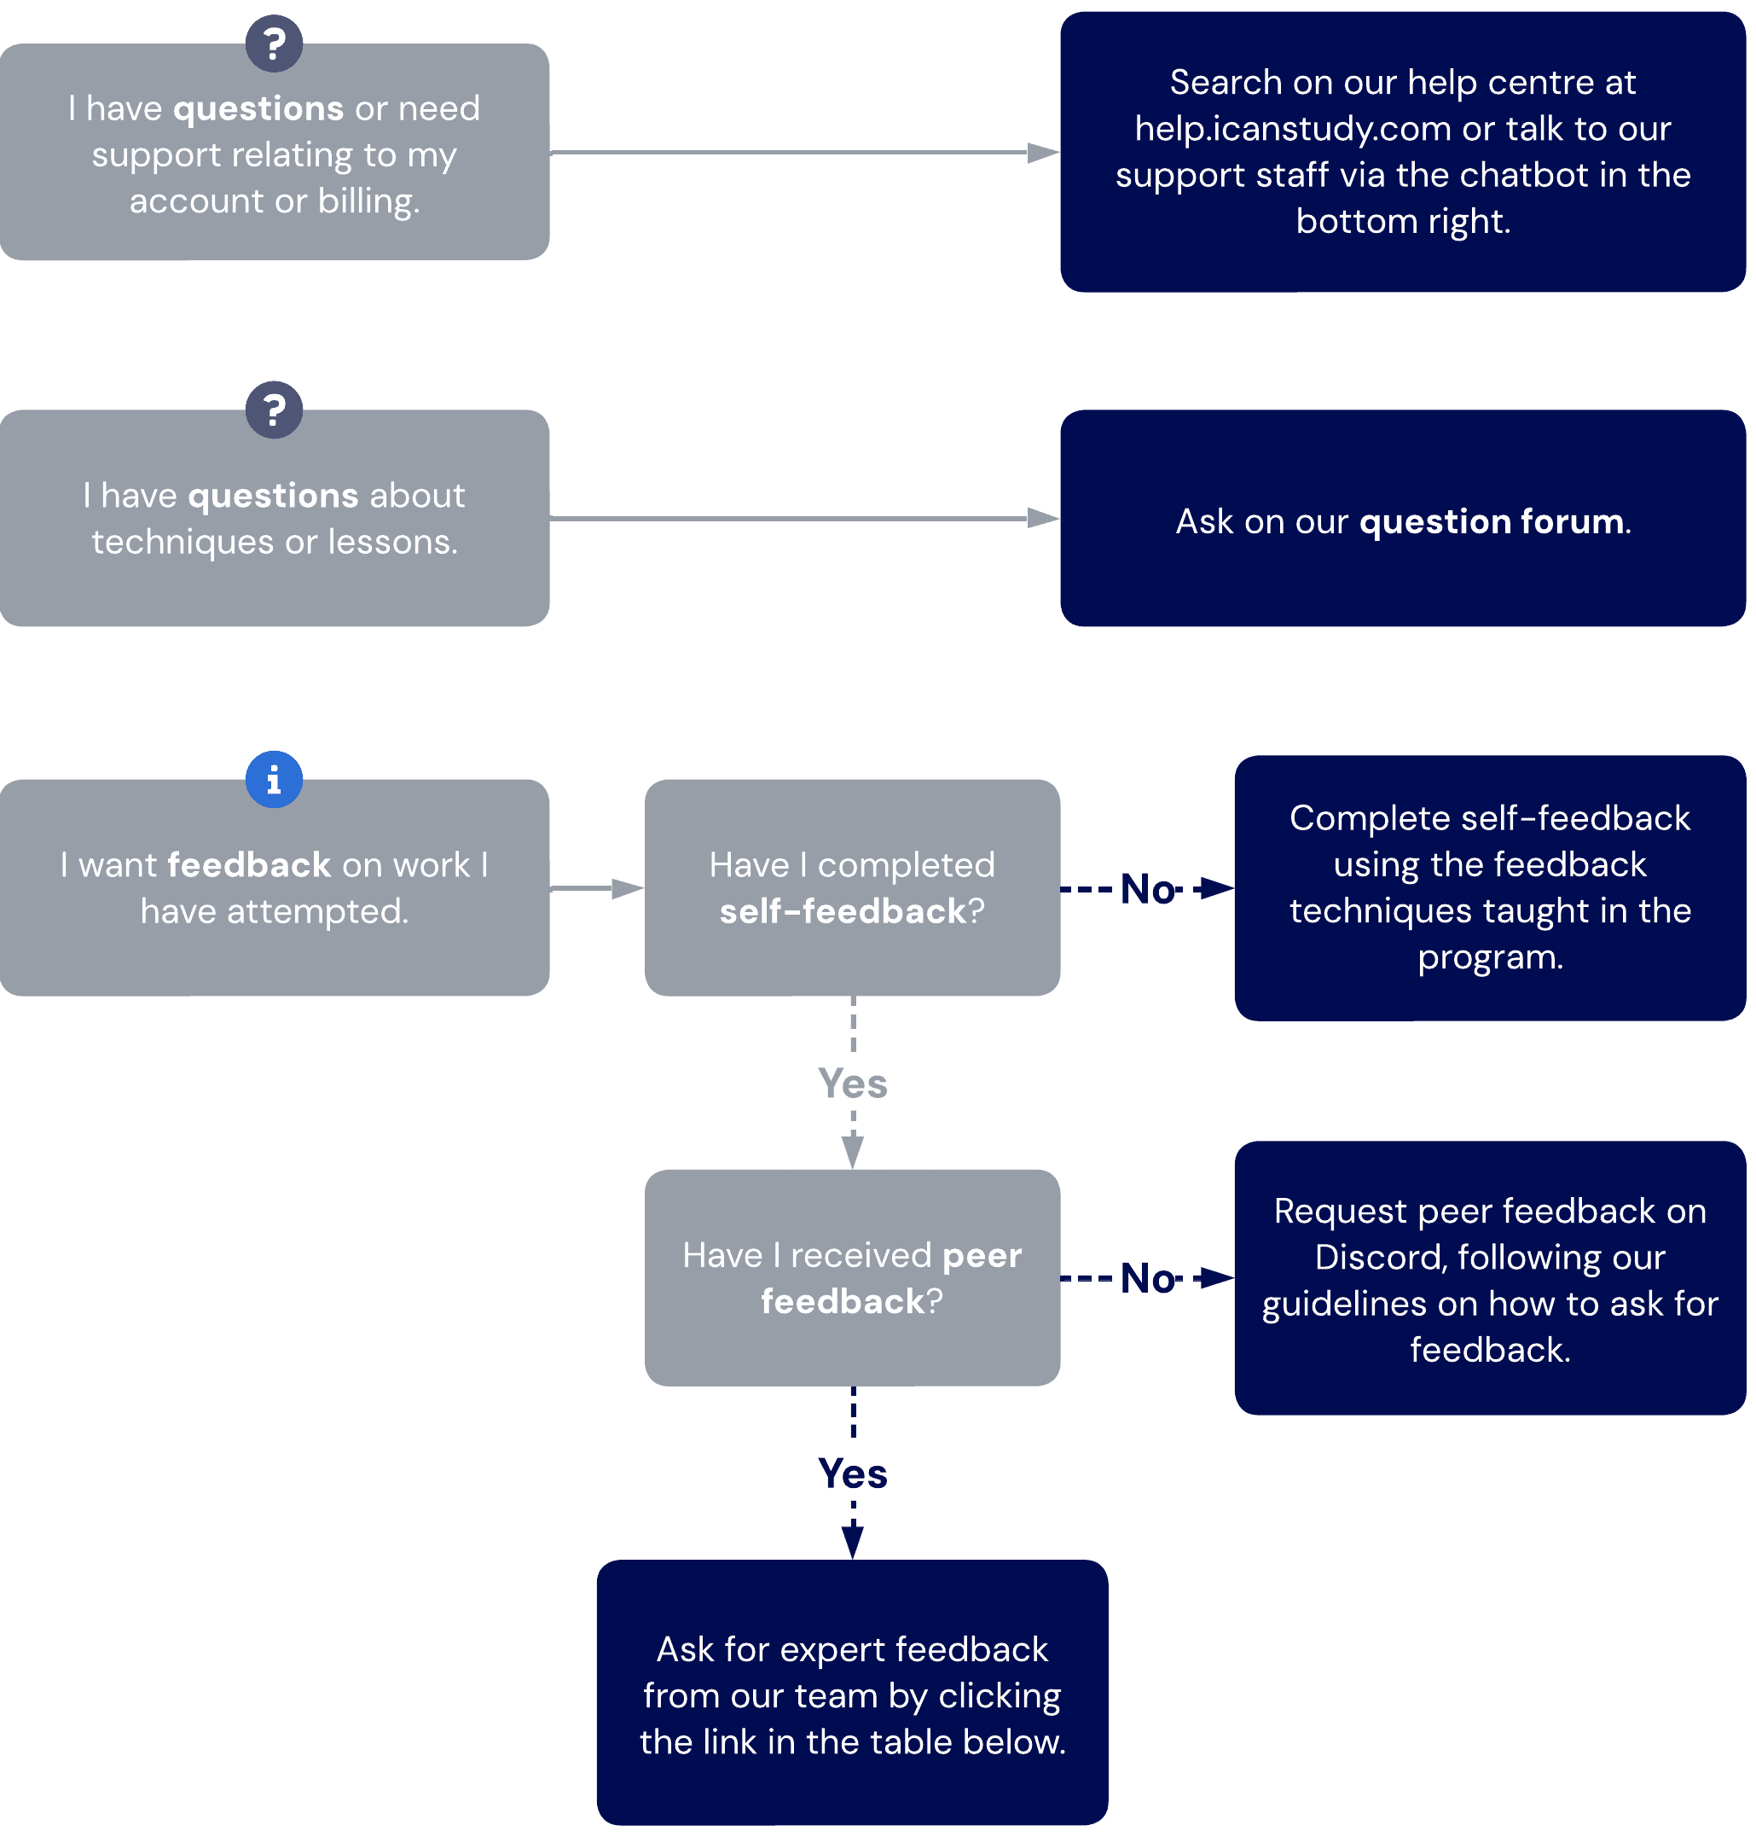The information in this flowchart is also described in the descriptions and table below.
Get answers to your questions
Program-related and technique questions
If you have questions on theory, techniques, tasks, or principles in our program, rather than wanting feedback on your work, search for your query in the Learning Support hub. If it is not answered, you can submit your question to our forum here.
We're reading!
We regularly review the top-voted questions to provide additional support articles and answers.
Account-related questions
If your questions concern your account, billing, or technical support unrelated to learning techniques, please visit help.icanstudy.com or start a conversation with our chatbot.
Get feedback on your work
Getting feedback on your work is a crucial part of skill improvement. There are multiple ways to receive high-quality feedback.
Method | When | How
Self-feedback | This should always be the first way to create feedback. Giving self-feedback (and getting better at it) is a critical skill for self-regulated learning. It also dramatically reduces your error-feedback cycles, directly shortening your skill development time. | Use Kolb's, rapid skill screens, and skill audits as we instruct in the core program.
Peer feedback | Ask for peer feedback in our community from more experienced members when you want more regular check-ups. Feedback from our community members is often much faster than through our coaches, with feedback sometimes given within hours! | Ask in the appropriate Discord forum. Remember to follow our guidelines to ensure you get a high-quality and timely response.
Expert feedback | You can submit a request to our coaching team when you:  - Are facing a complicated issue that community members can't seem to help you with.  - You are wanting a total system check after completing an audit yourself.  - You have unique circumstances and challenges.  - Have stubborn mistakes and problems that you can't seem to overcome despite self-feedback and peer feedback.  Requesting expert feedback has a minimum wait time of 7 business days. | Click here to be evaluated for expert feedback. If our team feels that a ticket is necessary, you will be able to submit your work through the messenger window.  You must first disable any adblockers to allow our chatbot to load.
No feedback without self-feedback
Self-feedback is so important that it's a rule! We never give feedback to a learner who has not first tried their best to give self-feedback. Struggling to give yourself self-feedback is often a sign of inadequate theoretical understanding, self-awareness, meta-cognition, or reflective technique.
All of these are prerequisites for self-regulated learning.

